**10 macam query & screenshoot**

1. SELECT * FROM `obat` ORDER BY barcode DESC;

2. SELECT * FROM `obat` ORDER BY nama_obat ASC;

3. SELECT * FROM `obat` WHERE nama_obat LIKE '%dewasa%';

4. SELECT * FROM `obat` WHERE nama_obat LIKE '%anak%';

5. SELECT id_penjual, SUM(qty_stock) as total FROM obat GROUP BY id_penjual;

6. SELECT id_jenis, SUM(qty_stock) as total FROM obat GROUP BY id_jenis;

7. SELECT id_harga, SUM(qty_stock) as total FROM obat GROUP BY id_harga;

8. SELECT tahun, SUM(qty_stock) as total FROM obat GROUP BY tahun;

9. SELECT tahun, SUM(qty_stock) as total FROM obat WHERE tahun >= 2020 GROUP BY tahun ORDER BY tahun DESC;

10. SELECT tahun, SUM(qty_stock) as total FROM obat GROUP BY tahun ORDER BY tahun ASC;

11. SELECT tahun, SUM(qty_stock) as total FROM obat GROUP BY tahun ORDER BY tahun DESC

1. SELECT * FROM `obat` ORDER BY barcode DESC;

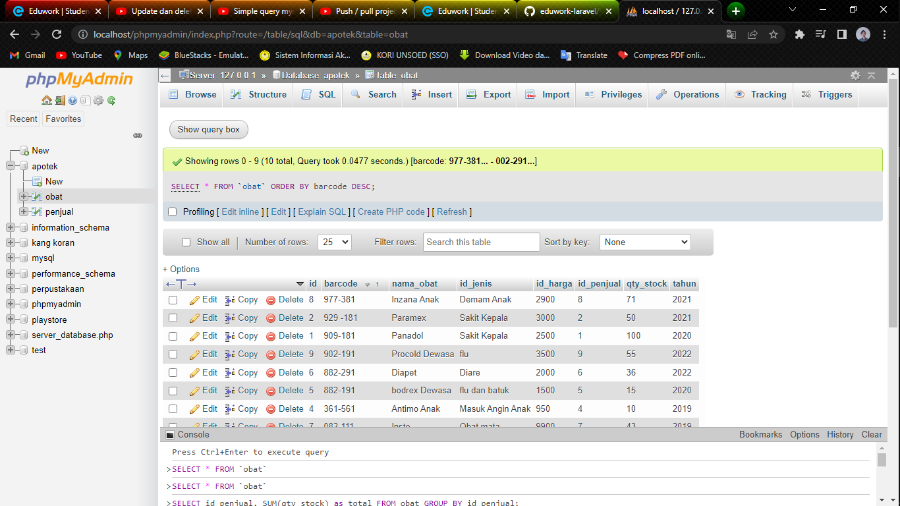

1. SELECT * FROM `obat` ORDER BY nama_obat ASC;

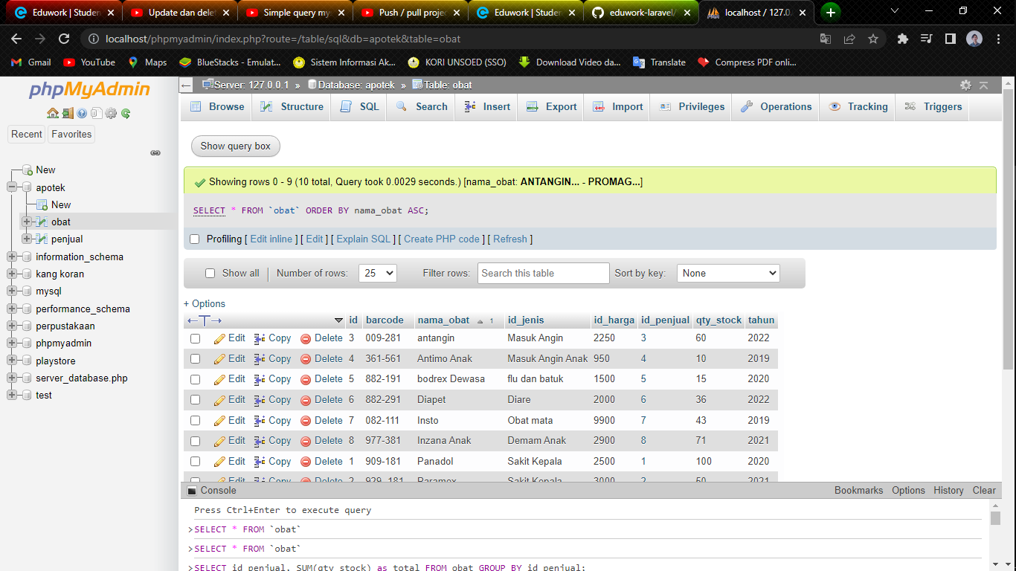

1. SELECT * FROM ‘obat’ WHERE nama_obat LIKE '%dewasa%';  
   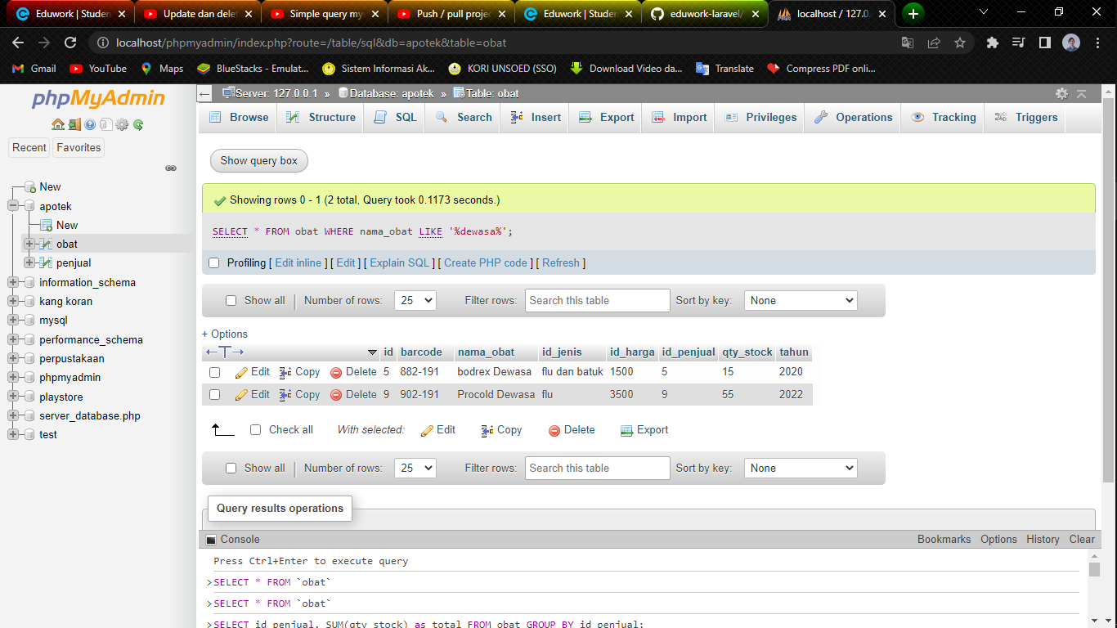
2. SELECT * FROM `obat` WHERE nama_obat LIKE '%anak%';

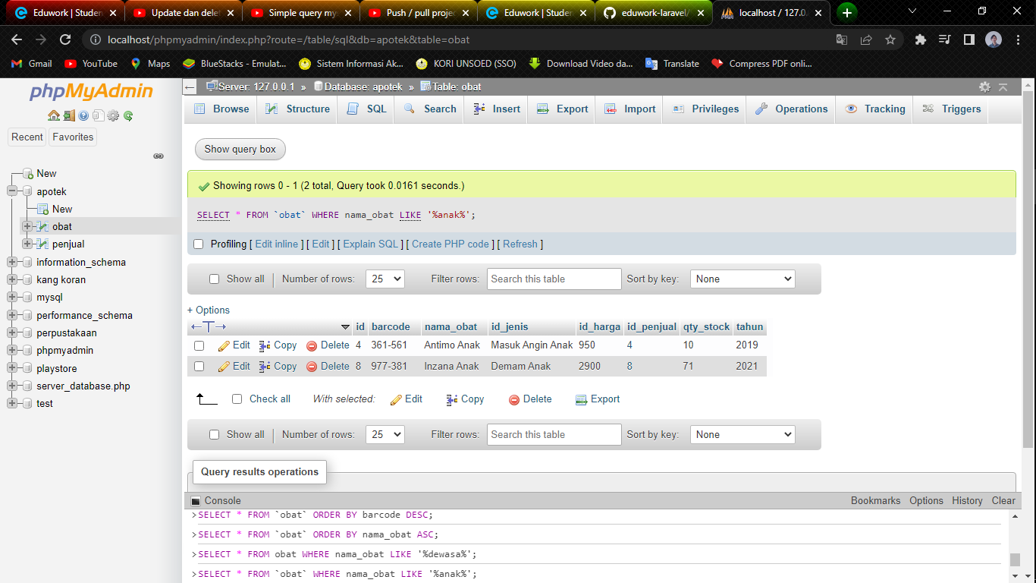

1. SELECT id_penjual, SUM(qty_stock) as total FROM obat GROUP BY id_penjual;

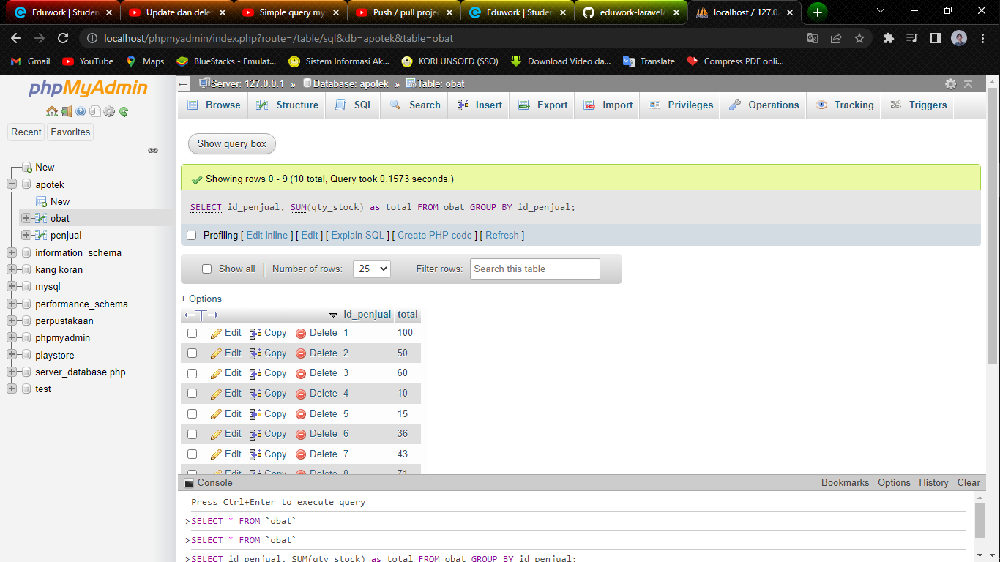

1. SELECT id_jenis, SUM(qty_stock) as total FROM obat GROUP BY id_jenis;

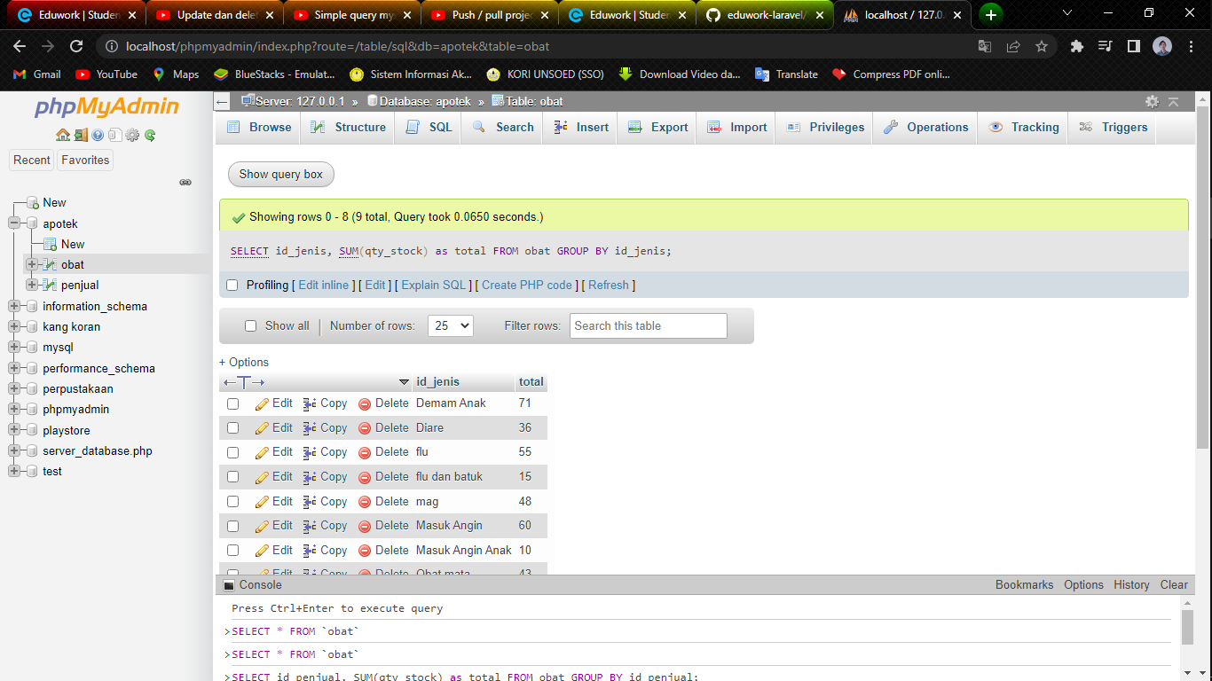

1. SELECT id_harga, SUM(qty_stock) as total FROM obat GROUP BY id_harga;

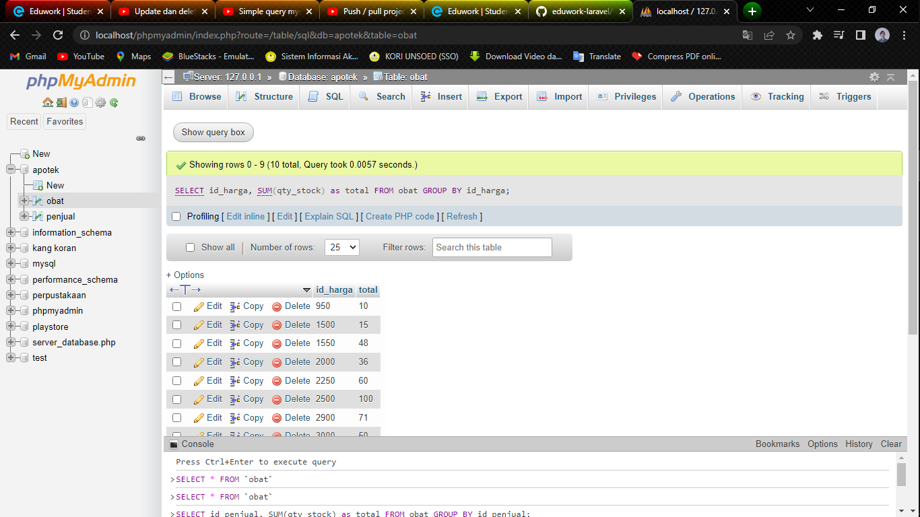

1. SELECT tahun, SUM(qty_stock) as total FROM obat GROUP BY tahun;

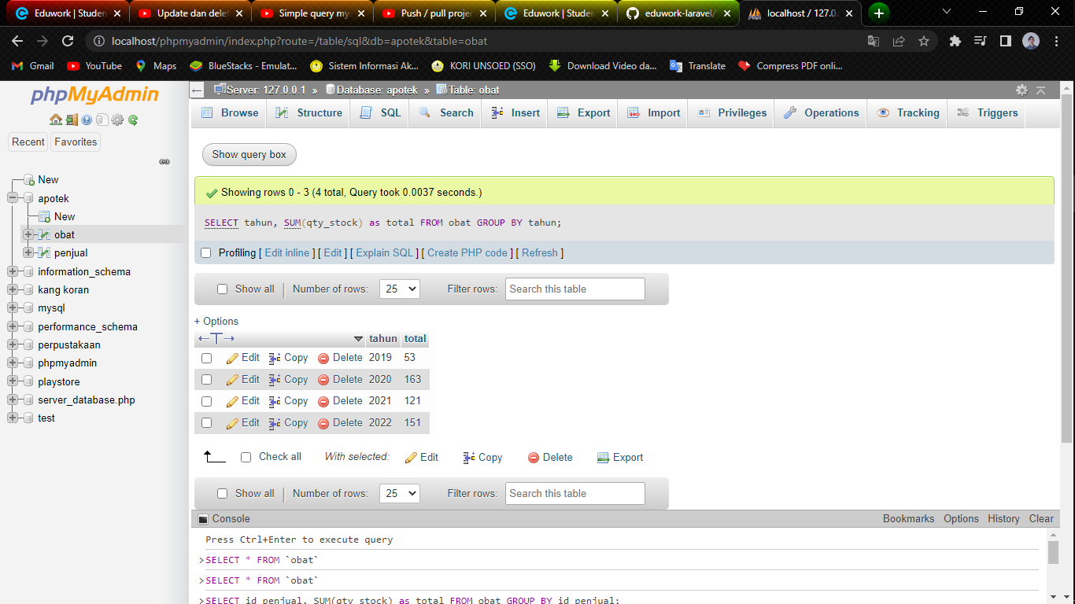

1. SELECT tahun, SUM(qty_stock) as total FROM obat WHERE tahun >= 2020 GROUP BY tahun ORDER BY tahun DESC;

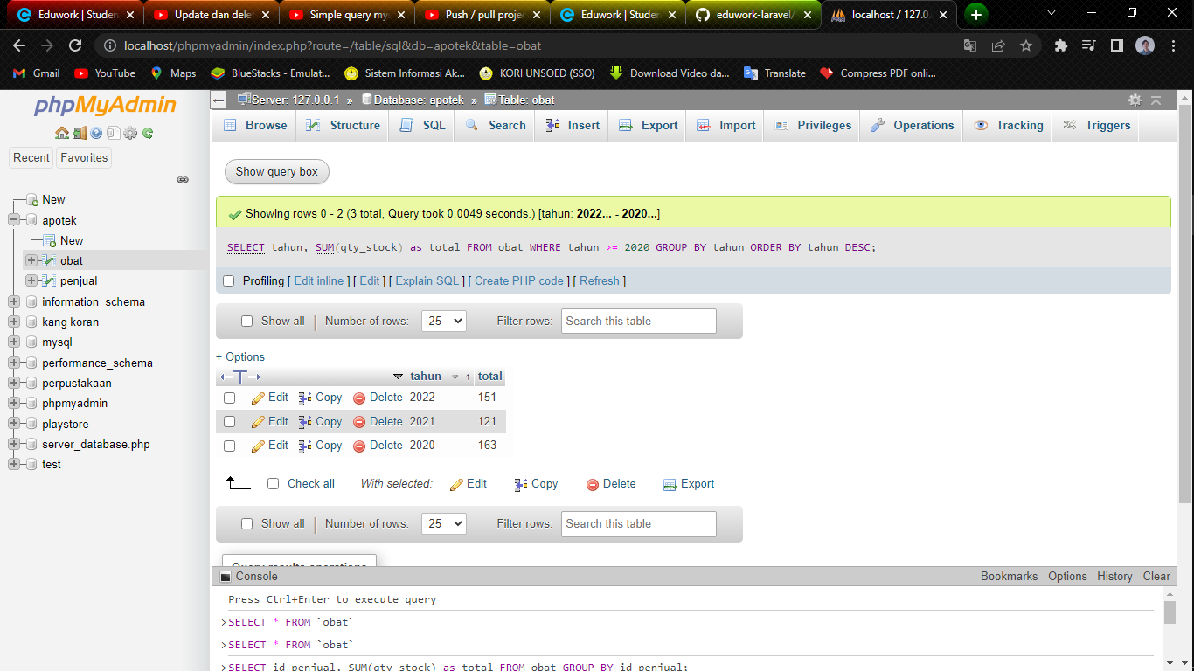

1. SELECT tahun, SUM(qty_stock) as total FROM obat GROUP BY tahun ORDER BY tahun ASC;

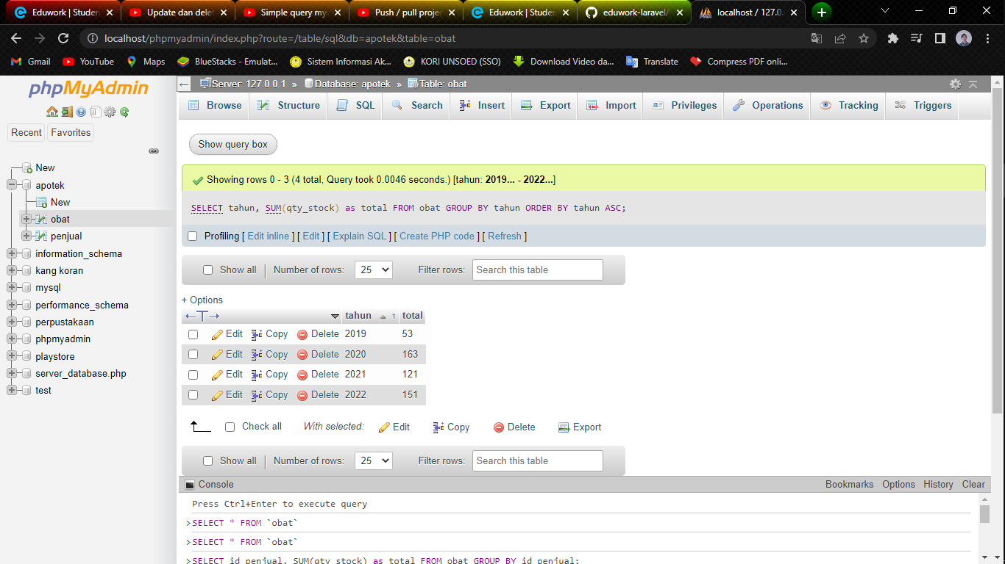

1. SELECT tahun, SUM(qty_stock) as total FROM obat GROUP BY tahun ORDER BY tahun DESC

